**WEEK – 8**

**1. Git-HOL**

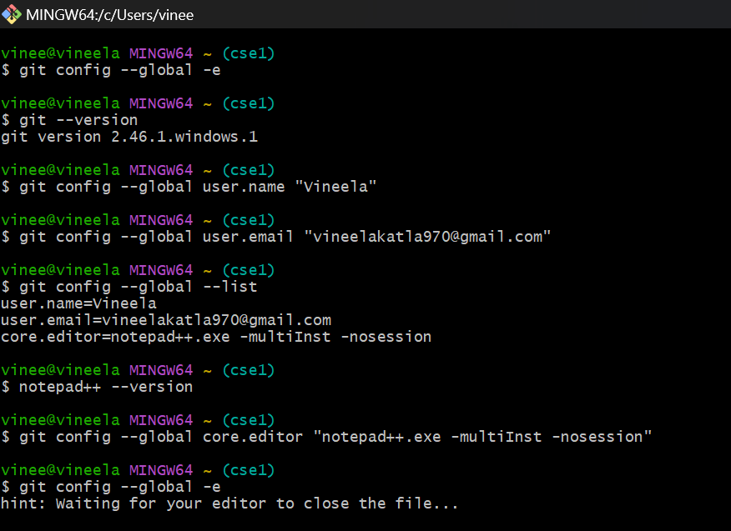

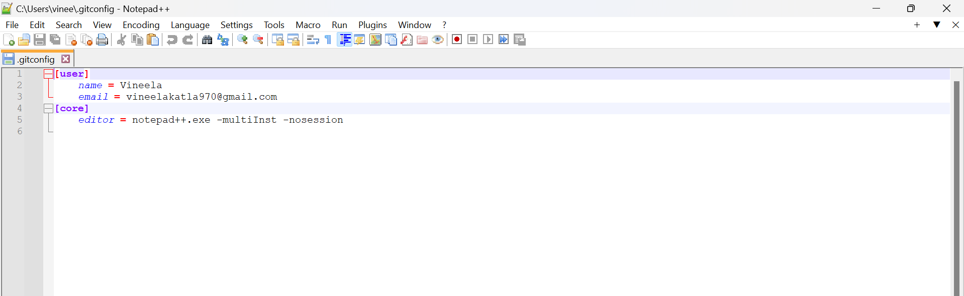

1. Open Git bash shell and create a new project “**GitDemo**”

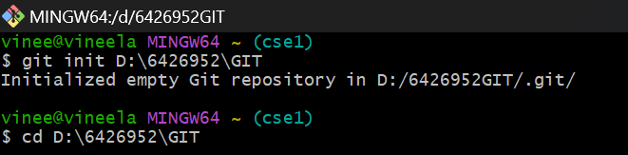

1. Verify



1. create a file **“welcome.txt”** and add content to the file
2. Verify if the file “welcome.txt” is created
3. Verify the content

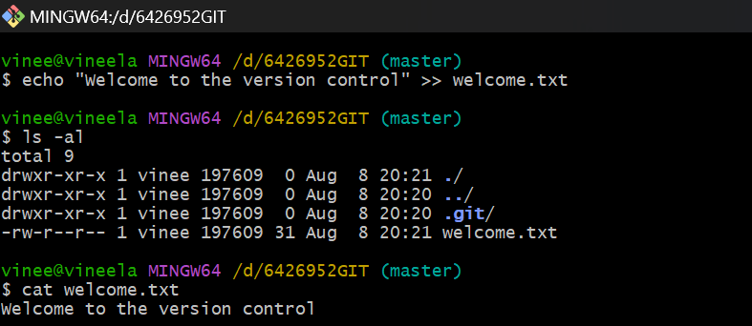

1. Check the status

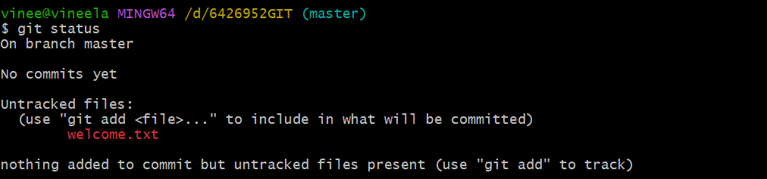

1. To make the file to be tracked by Git repository
2. add multi line comments, we are opening default editor to comment

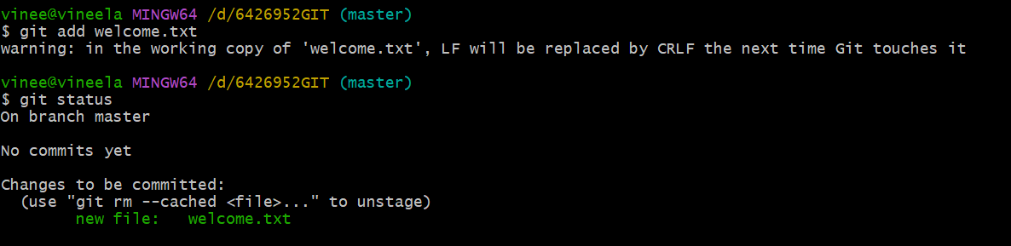

>git commit

This opens Notepad++. I have typed the following commit message:  
Add welcome.txt

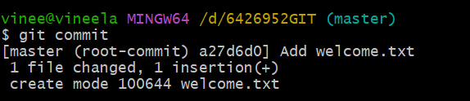

1. To check if local and “Working Directory” git repository are same, execute git status

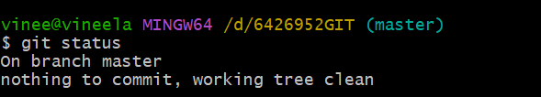

1. Signup with GitLab and create a remote repository **“GitDemo”**

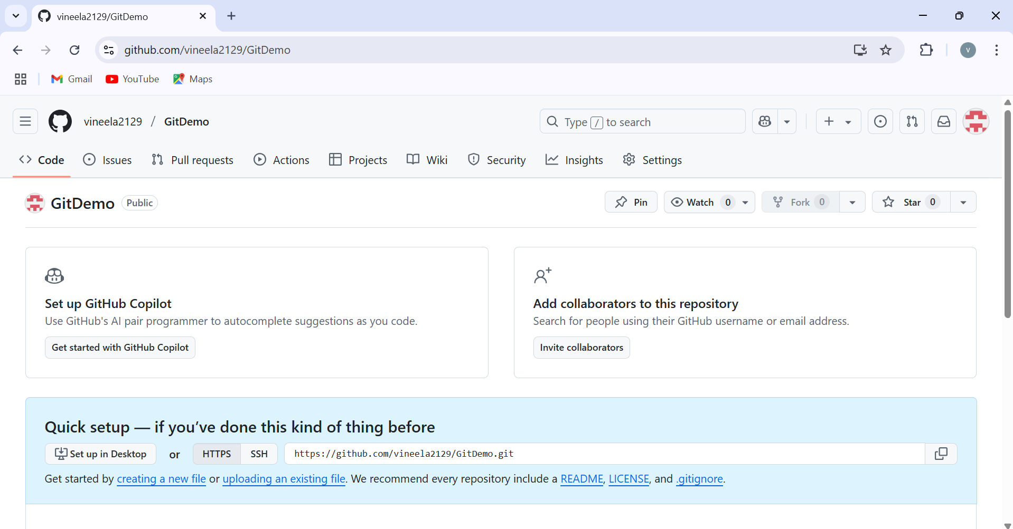

1. pull the remote repository
2. push the local to remote repository

